# SagePay Request/Response on UAT

## Status Response

### MALFORMED

2019-10-16 09:56:41,607 INFO 16 NesLog - PaymentHelper.ProcessPaymentInSagePay()

2019-10-16 09:56:41,794 INFO 16 NesLog - strPost::VPSProtocol=&TxType=PAYMENT&Vendor=nhseducation&VendorTxCode=f2ab7bdea82fe26d&Amount=249.00&Currency=GBP&Description=Services+from+NHS+Education+for+Scotland&NotificationURL=http://uat.portal.scot.nhs.uk/IBooklet/PaymentNotification?isMobile=False&BillingSurname=Paton&BillingFirstnames=Gordon&BillingAddress1=The Brambles&BillingAddress2=Little Hedgely&BillingCity=Burblington&BillingPostCode=NK12&BillingCountry=GB&BillingState=&BillingPhone=07795204591&DeliverySurname=Paton&DeliveryFirstnames=Gordon&DeliveryAddress1=The Brambles&DeliveryAddress2=Little Hedgely&DeliveryCity=Burblington&DeliveryPostCode=NK12&DeliveryCountry=GB&DeliveryState=&DeliveryPhone=07795204591&CustomerEMail=ggp.public%40gmail.com&Basket=1%3aAzure+Test%3a%3a%3a%3a%3a249.00&AllowGiftAid=0&ApplyAVSCV2=0&Apply3DSecure=&Profile=NORMAL

2019-10-16 09:56:42,107 INFO 16 NesLog - ------------------------------------------------------------

2019-10-16 09:56:42,107 INFO 16 NesLog - strResponse::VPSProtocol=3.00

Status=MALFORMED

StatusDetail=3096 : The VPSProtocol value is required.

VPSTxId={2872800E-DB3A-B0DE-85FC-26FA87ECFEF9}

### OK

2019-10-16 10:00:16,333 INFO 25 NesLog - PaymentHelper.ProcessPaymentInSagePay()

2019-10-16 10:00:16,536 INFO 25 NesLog - strPost::VPSProtocol=3.0&TxType=PAYMENT&Vendor=nhseducation&VendorTxCode=21c66c3bc4541e0b&Amount=249.00&Currency=GBP&Description=Services+from+NHS+Education+for+Scotland&NotificationURL=http://uat.portal.scot.nhs.uk/IBooklet/PaymentNotification?isMobile=False&BillingSurname=Paton&BillingFirstnames=Gordon&BillingAddress1=The Brambles&BillingAddress2=Little Hedgely&BillingCity=Burblington&BillingPostCode=NK12&BillingCountry=GB&BillingState=&BillingPhone=07795204591&DeliverySurname=Paton&DeliveryFirstnames=Gordon&DeliveryAddress1=The Brambles&DeliveryAddress2=Little Hedgely&DeliveryCity=Burblington&DeliveryPostCode=NK12&DeliveryCountry=GB&DeliveryState=&DeliveryPhone=07795204591&CustomerEMail=ggp.public%40gmail.com&Basket=1%3aAzure+Test%3a%3a%3a%3a%3a249.00&AllowGiftAid=0&ApplyAVSCV2=0&Apply3DSecure=0&Profile=NORMAL

2019-10-16 10:00:16,975 INFO 25 NesLog - ------------------------------------------------------------

2019-10-16 10:00:16,975 INFO 25 NesLog - strResponse::VPSProtocol=3.00

Status=OK

StatusDetail=2014 : The Transaction was Registered Successfully.

VPSTxId={16AEC541-0F53-3726-0809-BFE2A1FD4C5D}

SecurityKey=UELR8KVSFO

NextURL=https://test.sagepay.com/gateway/service/cardselection?vpstxid={16AEC541-0F53-3726-0809-BFE2A1FD4C5D}

### OK – 3DSecure

2019-10-16 10:40:52,893 INFO 79 NesLog - PaymentHelper.ProcessPaymentInSagePay()

2019-10-16 10:40:53,096 INFO 79 NesLog - ------------------------------------------------------------

2019-10-16 10:40:53,096 INFO 79 NesLog - strPost::VPSProtocol=3.0&TxType=PAYMENT&Vendor=nhseducation&VendorTxCode=12505fe68295b332&Amount=249.00&Currency=GBP&Description=Services+from+NHS+Education+for+Scotland&NotificationURL=http://uat.portal.scot.nhs.uk/IBooklet/PaymentNotification?isMobile=False&BillingSurname=Paton&BillingFirstnames=Gordon&BillingAddress1=The Brambles&BillingAddress2=Little Hedgely&BillingCity=Burblington&BillingPostCode=NK12&BillingCountry=GB&BillingState=&BillingPhone=07795204591&DeliverySurname=Paton&DeliveryFirstnames=Gordon&DeliveryAddress1=The Brambles&DeliveryAddress2=Little Hedgely&DeliveryCity=Burblington&DeliveryPostCode=NK12&DeliveryCountry=GB&DeliveryState=&DeliveryPhone=07795204591&CustomerEMail=ggp.public%40gmail.com&Basket=1%3aAzure+Test%3a%3a%3a%3a%3a249.00&AllowGiftAid=0&ApplyAVSCV2=0&Apply3DSecure=1&Profile=NORMAL

2019-10-16 10:40:53,237 INFO 79 NesLog - -

2019-10-16 10:40:53,237 INFO 79 NesLog - strResponse::VPSProtocol=3.00

Status=OK

StatusDetail=2014 : The Transaction was Registered Successfully.

VPSTxId={55583A8A-73E5-479F-92B4-333BB68F376C}

SecurityKey=UJ7FYPVHKA

NextURL=https://test.sagepay.com/gateway/service/cardselection?vpstxid={55583A8A-73E5-479F-92B4-333BB68F376C}

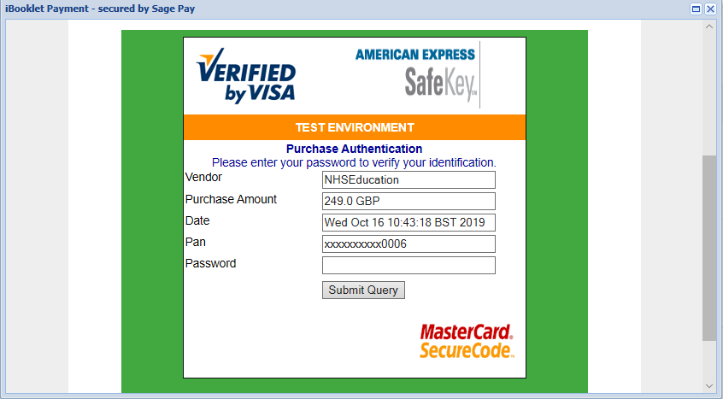

Password = fred

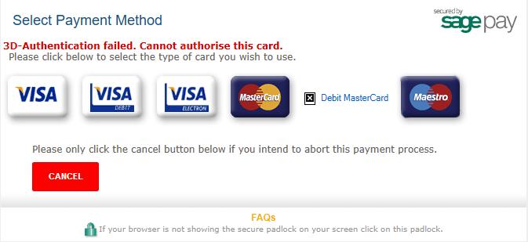

2019-10-16 11:32:18,235 INFO 31 NesLog - PaymentHelper.ProcessPaymentInSagePay()

2019-10-16 11:32:18,423 INFO 31 NesLog - ------------------------------------------------------------

2019-10-16 11:32:18,423 INFO 31 NesLog - strPost::VPSProtocol=3.0&TxType=PAYMENT&Vendor=nhseducation&VendorTxCode=e6fc080596fbccae&Amount=249.00&Currency=GBP&Description=Services+from+NHS+Education+for+Scotland&NotificationURL=http://uat.portal.scot.nhs.uk/IBooklet/PaymentNotification?isMobile=False&BillingSurname=Paton&BillingFirstnames=Gordon&BillingAddress1=The Brambles&BillingAddress2=Little Hedgely&BillingCity=Burblington&BillingPostCode=NK12&BillingCountry=GB&BillingState=&BillingPhone=07795204591&DeliverySurname=Paton&DeliveryFirstnames=Gordon&DeliveryAddress1=The Brambles&DeliveryAddress2=Little Hedgely&DeliveryCity=Burblington&DeliveryPostCode=NK12&DeliveryCountry=GB&DeliveryState=&DeliveryPhone=07795204591&CustomerEMail=ggp.public%40gmail.com&Basket=1%3aAzure+Test%3a%3a%3a%3a%3a249.00&AllowGiftAid=0&ApplyAVSCV2=0&Apply3DSecure=1&Profile=NORMAL

2019-10-16 11:32:18,704 INFO 31 NesLog - -

2019-10-16 11:32:18,704 INFO 31 NesLog - strResponse::VPSProtocol=3.00

Status=OK

StatusDetail=2014 : The Transaction was Registered Successfully.

VPSTxId={3288D171-B8B4-9CB3-CAB0-6940CDF8FACA}

SecurityKey=HSHDDLZRES

NextURL=https://test.sagepay.com/gateway/service/cardselection?vpstxid={3288D171-B8B4-9CB3-CAB0-6940CDF8FACA}

CLICK CANCEL

2019-10-16 11:35:57,527 INFO 22 NesLog - ------------------------------------------------------------

2019-10-16 11:35:57,527 INFO 22 NesLog - iBooklet/PaymentNotification()

2019-10-16 11:35:57,542 INFO 22 NesLog - PaymentHelper/PaymentNotification()

2019-10-16 11:35:57,558 INFO 22 NesLog - Status:: INVALID

2019-10-16 11:35:57,558 INFO 22 NesLog - StatusDetail:: Cannot match the MD5 Hash. Order might be tampered with.

2019-10-16 11:35:57,558 INFO 22 NesLog - RedirectURL:: http://uat.portal.scot.nhs.uk/IBooklet/PaymentErrorKeyMismatch?userID=00000000-0000-0000-0000-000000000000

2019-10-16 11:37:02,169 INFO 49 NesLog - ------------------------------------------------------------

2019-10-16 11:37:02,169 INFO 49 NesLog - iBooklet/PaymentNotification()

2019-10-16 11:37:02,169 INFO 49 NesLog - PaymentHelper/PaymentNotification()

2019-10-16 11:37:02,185 INFO 49 NesLog - Status:: INVALID

2019-10-16 11:37:02,185 INFO 49 NesLog - StatusDetail:: Cannot match the MD5 Hash. Order might be tampered with.

2019-10-16 11:37:02,185 INFO 49 NesLog - RedirectURL:: <http://uat.portal.scot.nhs.uk/IBooklet/PaymentErrorKeyMismatch?userID=00000000-0000-0000-0000-000000000000>

2019-10-16 14:05:55,415 INFO 5 NesLog - PaymentHelper.ProcessPaymentInSagePay()

2019-10-16 14:05:55,618 INFO 5 NesLog - ------------------------------------------------------------

2019-10-16 14:05:55,618 INFO 5 NesLog - strPost::VPSProtocol=3.0&TxType=PAYMENT&Vendor=nhseducation&VendorTxCode=5f5b84e7ebe7411a&Amount=249.00&Currency=GBP&Description=Services+from+NHS+Education+for+Scotland&NotificationURL=http://uat.portal.scot.nhs.uk/IBooklet/PaymentNotification?isMobile=False&BillingSurname=Paton&BillingFirstnames=Gordon&BillingAddress1=The Brambles&BillingAddress2=Little Hedgely&BillingCity=Burblington&BillingPostCode=NK12&BillingCountry=GB&BillingState=&BillingPhone=07795204591&DeliverySurname=Paton&DeliveryFirstnames=Gordon&DeliveryAddress1=The Brambles&DeliveryAddress2=Little Hedgely&DeliveryCity=Burblington&DeliveryPostCode=NK12&DeliveryCountry=GB&DeliveryState=&DeliveryPhone=07795204591&CustomerEMail=ggp.public%40gmail.com&Basket=1%3aAzure+Test%3a%3a%3a%3a%3a249.00&AllowGiftAid=0&ApplyAVSCV2=0&Apply3DSecure=1&Profile=NORMAL

2019-10-16 14:05:55,884 INFO 5 NesLog - -

2019-10-16 14:05:55,884 INFO 5 NesLog - strResponse::VPSProtocol=3.00

Status=OK

StatusDetail=2014 : The Transaction was Registered Successfully.

VPSTxId={DB1C0F95-3B9A-AC7A-B884-B69A41FF6CE0}

SecurityKey=682IQBOE24

NextURL=https://test.sagepay.com/gateway/service/cardselection?vpstxid={DB1C0F95-3B9A-AC7A-B884-B69A41FF6CE0}

2019-10-16 14:07:46,542 INFO 14 NesLog - ------------------------------------------------------------

2019-10-16 14:07:46,542 INFO 14 NesLog - iBooklet/PaymentNotification()

2019-10-16 14:07:46,542 INFO 14 NesLog - PaymentHelper/PaymentNotification()

2019-10-16 14:07:46,573 INFO 14 NesLog - Status:: INVALID

2019-10-16 14:07:46,573 INFO 14 NesLog - StatusDetail:: Cannot match the MD5 Hash. Order might be tampered with.

2019-10-16 14:07:46,573 INFO 14 NesLog - RedirectURL:: <http://uat.portal.scot.nhs.uk/IBooklet/PaymentErrorKeyMismatch?userID=00000000-0000-0000-0000-000000000000>

## Successful 3D Auth

2019-10-17 10:50:10,064 INFO 11 NesLog - PaymentHelper.ProcessPaymentInSagePay()

2019-10-17 10:50:10,251 INFO 11 NesLog - ------------------------------------------------------------

2019-10-17 10:50:10,251 INFO 11 NesLog - strPost::VPSProtocol=3.0&TxType=PAYMENT&Vendor=nhseducation&VendorTxCode=36f41e9fe296d09d&Amount=249.00&Currency=GBP&Description=Services+from+NHS+Education+for+Scotland&NotificationURL=http://uat.portal.scot.nhs.uk/IBooklet/PaymentNotification?isMobile=False&BillingSurname=Paton&BillingFirstnames=Gordon&BillingAddress1=The Brambles&BillingAddress2=Little Hedgely&BillingCity=Burblington&BillingPostCode=NK12&BillingCountry=GB&BillingState=&BillingPhone=07795204591&DeliverySurname=Paton&DeliveryFirstnames=Gordon&DeliveryAddress1=The Brambles&DeliveryAddress2=Little Hedgely&DeliveryCity=Burblington&DeliveryPostCode=NK12&DeliveryCountry=GB&DeliveryState=&DeliveryPhone=07795204591&CustomerEMail=ggp.public%40gmail.com&Basket=1%3aAzure+Test%3a%3a%3a%3a%3a249.00&AllowGiftAid=0&ApplyAVSCV2=0&Apply3DSecure=1&Profile=NORMAL

2019-10-17 10:50:10,584 INFO 11 NesLog - -

2019-10-17 10:50:10,584 INFO 11 NesLog - strResponse::VPSProtocol=3.00

Status=OK

StatusDetail=2014 : The Transaction was Registered Successfully.

VPSTxId={1700F074-2285-C4FA-64CE-079FD968EE08}

SecurityKey=W1DQ2FWLYV

NextURL=https://test.sagepay.com/gateway/service/cardselection?vpstxid={1700F074-2285-C4FA-64CE-079FD968EE08}

2019-10-17 10:50:46,096 INFO 10 NesLog - ------------------------------------------------------------

2019-10-17 10:50:46,096 INFO 10 NesLog - iBooklet/PaymentNotification()

2019-10-17 10:50:46,112 INFO 10 NesLog - PaymentHelper/PaymentNotification()

2019-10-17 10:50:46,127 INFO 10 NesLog - -----------------------------------

2019-10-17 10:50:46,127 INFO 10 NesLog - strMySignature

2019-10-17 10:50:46,127 INFO 10 NesLog - FEB7A6EA855FA3CA540422A3F27A3FAD

2019-10-17 10:50:46,127 INFO 10 NesLog - -----------------------------------

2019-10-17 10:50:46,127 INFO 10 NesLog - strMySignature

2019-10-17 10:50:46,127 INFO 10 NesLog - FEB7A6EA855FA3CA540422A3F27A3FAD

2019-10-17 10:50:46,127 INFO 10 NesLog - -----------------------------------

2019-10-17 10:50:50,982 INFO 10 NesLog - Status:: OK

2019-10-17 10:50:50,982 INFO 10 NesLog - StatusDetail::

2019-10-17 10:50:50,982 INFO 10 NesLog - RedirectURL:: http://uat.portal.scot.nhs.uk/IBooklet/BookingConfirm?userID=31d97acd-e1f8-414d-a4cd-ebc7aca8291e